TEST 1: Legacy Instructions

Purpose: This test includes all the legacy XM-2 instructions. Verify the preprocessor working well on all of instructions

Configuration: ./preprocessor test_legacy_inst.asm

Expected Result:

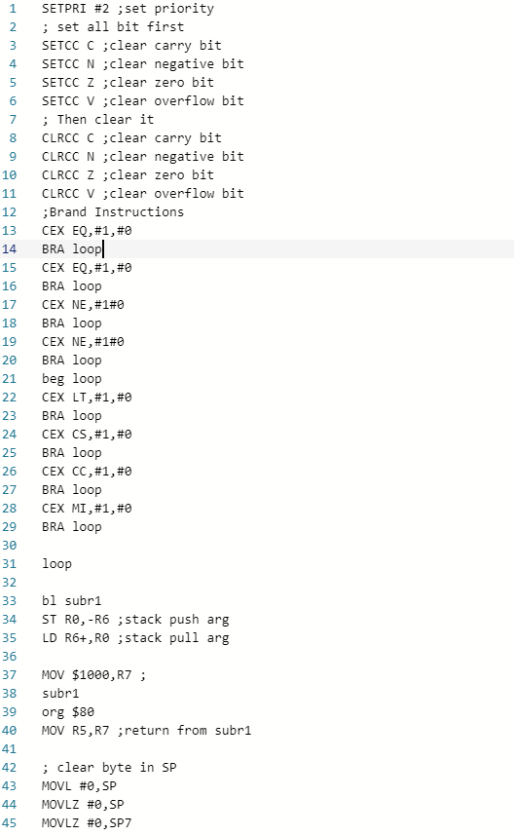

Actual Result:

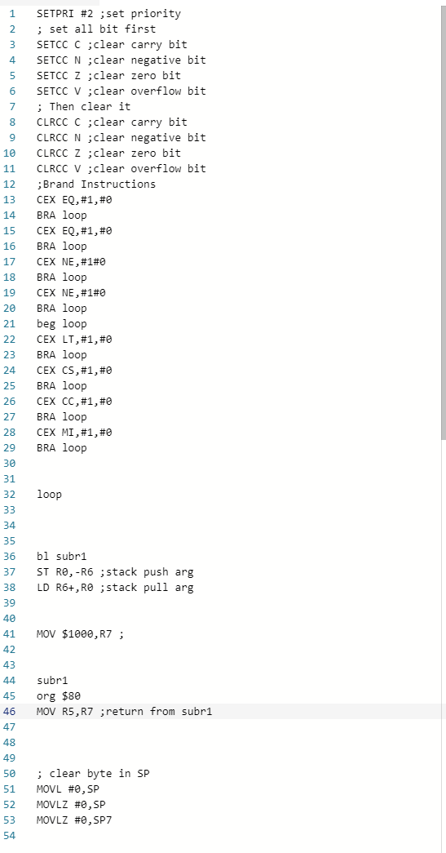

It is correct, match the expectation

TEST 2: Inst After Comm

Purpose: This test verifies that the XM2 inst after ‘;’ won’t influence the preprocessor, it will be automatically ignored

Configuration: ./preprocessor test_comm_inst.asm

Expected Result:

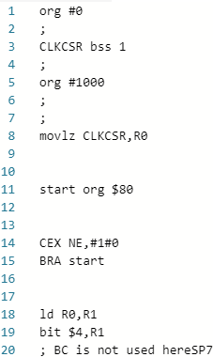

Actual Result:



It is correct, match the expectation

TEST 3: Label Recognition

Purpose: This test uses many labels, in order to see whether these labels may cause error in preprocessors

Configuration: ./preprocessor test_label.asm

Expected Result:

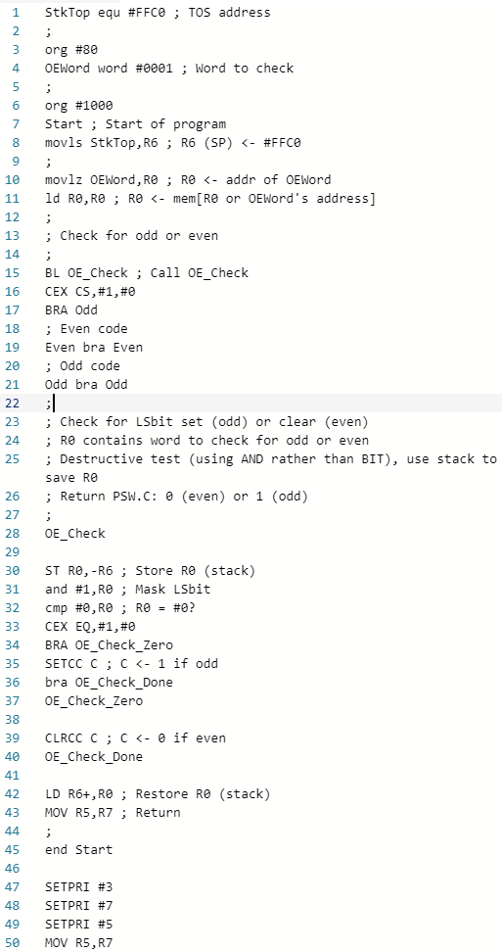

Actual Result:



It is correct, match the expectation

TEST 4: Error Handling

Purpose: Test whether the error handling works. Set instructions without operand which should be with operand. See the corresponding error message.

Configuration: ./preprocessor test_error_handle.asm

Expected Result:

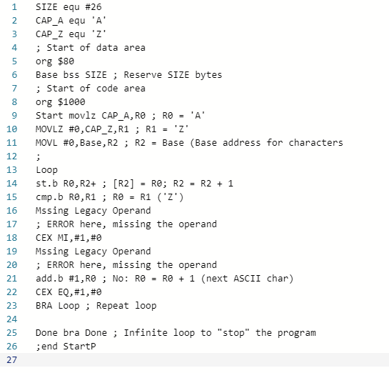

Actual Result:



It is correct, match the expectation

TEST 5: All Instructions

Purpose: List all instructions and put into test

Configuration: ./preprocessor test_all_inst.asm

Expected Result:

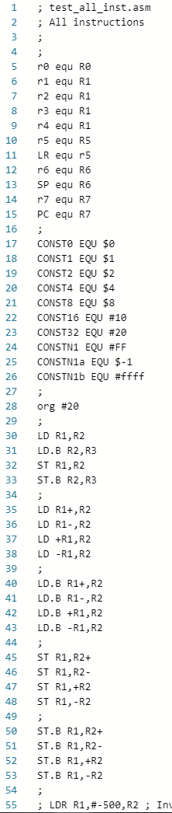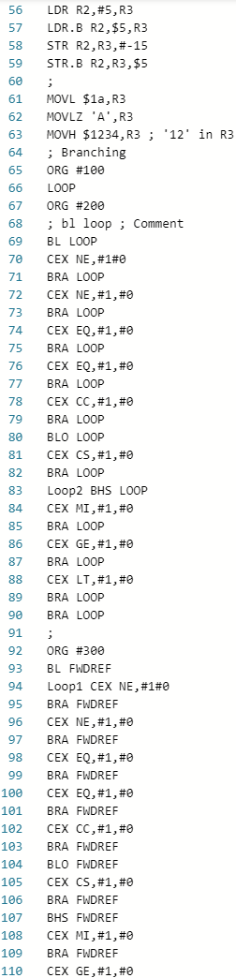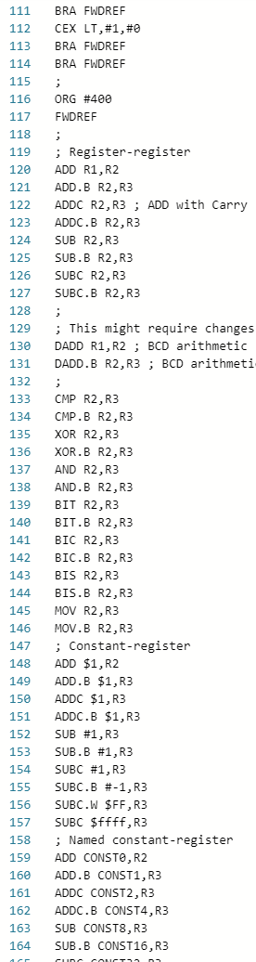

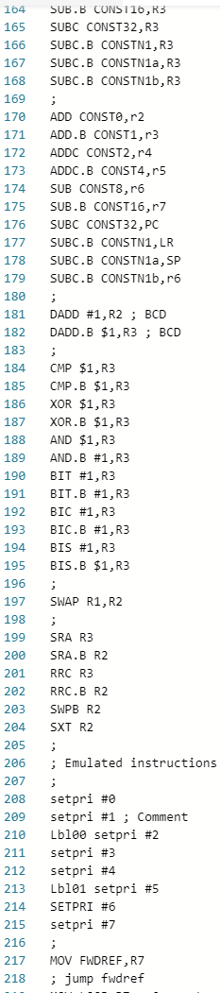 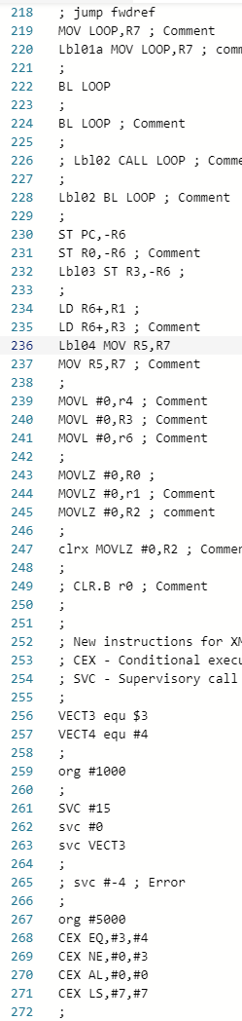 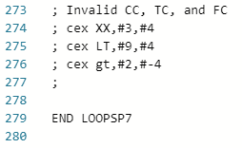

Actual Result:



  

It is correct, match the expectation